
PROJECT 300 DOCUMENTATION
Course Name : Web Development and Project

Submitted To:
Abdul Wadud Shakib
Lecturer,
Department of Computer Science & Engineering
Metropolitan University, Bangladesh
Submitted By:
Muzahidul Islam
ID : 241-115-064
Batch: 60th , Section : B
Department of Computer Science and Engineering
Metropolitan University, Bangladesh
Date of Submission :

MotoGT: A Full-Stack Car Accessories and Dent & Paint Service Website

1. Project Title
MotoGT: A Full-Stack Car Accessories and Dent & Paint Service Website

2. Project Idea
MotoGT is a web-based platform designed to showcase car accessories and dent and paint services. The website will allow customers to browse available products, explore automotive services, create accounts, and place orders online. Customers will also be able to contact the business through an enquiry form.
An administrator will be able to manage products, view and update customer orders, and handle enquiries through an administrative dashboard. The system aims to provide a convenient and organized online experience for both customers and the business owner.

3. Project Objectives
The main objectives of the MotoGT project are:
- To develop a modern, responsive, and user-friendly website for MotoGT.
- To display car accessories with relevant information, prices, and product images.
- To provide information about dent repair, painting, and other automotive services.
- To implement customer registration, login, and authentication.
- To enable customers to manage a shopping cart and place orders online.
- To provide a contact and enquiry system for customer communication.
- To create an administrative dashboard for managing products, orders, and enquiries.
- To store and manage product, customer, and order information in a database.
- To improve the online accessibility and visibility of the MotoGT business.
- To maintain the security, reliability, usability, and maintainability of the website.

4. Functional Requirements
Functional requirements describe the operations that the system is expected to perform.
- FR-01 — Product Catalogue: The system shall display available car accessories with product names, images, descriptions, and prices.
- FR-02 — Product Details: Customers shall be able to view detailed information about individual products.
- FR-03 — Customer Registration: New customers shall be able to create an account.
- FR-04 — Customer Login: Registered customers shall be able to log in securely.
- FR-05 — Shopping Cart: Customers shall be able to add products to the cart, update quantities, and remove items.
- FR-06 — Order Placement: Customers shall be able to submit orders and provide the required order or delivery information.
- FR-07 — Order Tracking: Customers shall be able to view their order details and status, if this functionality is implemented.
- FR-08 — Service Information: The system shall display information about dent repair, paintwork, and other services offered by MotoGT.
- FR-09 — Contact and Enquiry: Customers shall be able to submit enquiries through a contact form.
- FR-10 — Admin Authentication: Authorized administrators shall be able to access the administrative dashboard.
- FR-11 — Product Management: Administrators shall be able to add, edit, and remove product listings.
- FR-12 — Order Management: Administrators shall be able to view orders and update their statuses.
- FR-13 — Enquiry Management: Administrators shall be able to view and manage customer enquiries.
- FR-14 — Access Control: The system shall restrict administrative operations to authorized administrators.

5. Non-Functional Requirements
Non-functional requirements define the expected quality and operational characteristics of the system.
- NFR-01 — Usability: The website should provide a clear and easy-to-use interface.
- NFR-02 — Responsiveness: The website should adapt to desktop, tablet, and mobile screen sizes.
- NFR-03 — Security: Passwords should be securely hashed, and protected features should require appropriate authentication and authorization.
- NFR-04 — Performance: Pages and product listings should load efficiently under normal operating conditions.
- NFR-05 — Reliability: The system should handle invalid inputs and common errors appropriately.
- NFR-06 — Data Integrity: Product, customer, and order information should be stored consistently.
- NFR-07 — Maintainability: The application should use a modular structure to simplify future updates.
- NFR-08 — Compatibility: The website should support modern web browsers.
- NFR-09 — Availability: The deployed website should be accessible when its hosting service is operational.
- NFR-10 — Privacy: Customer information should be handled appropriately and protected against unauthorized access.

6. Initial Technology Selection
The following technologies have been selected for the planned development of MotoGT.
Component | Selected Technology
Frontend Framework | React.js
Frontend Build Tool | Vite
Styling | CSS
Backend Runtime | Node.js
Backend Framework | Express.js
Database | MongoDB
Database Library | Mongoose
IDE | Visual Studio Code
Version Control | Git
Remote Repository | GitHub
Development Platform | Node.js-based environment
Browser Testing | Google Chrome or another modern browser

6.1 Justification for Technology Selection
React.js supports reusable UI components and interactive user interfaces, while Vite provides a convenient frontend development and build environment. Node.js and Express.js support backend application logic and API development. MongoDB can store product, customer, order, and enquiry data, while Mongoose helps define data models and interact with the database.
Visual Studio Code will be used to write and manage the source code. Git and GitHub will support version control, project history, and source-code management.

7. Initial System Design
This section presents the planned system structure and the diagrams required for the initial design.

7.1 Use Case Diagram
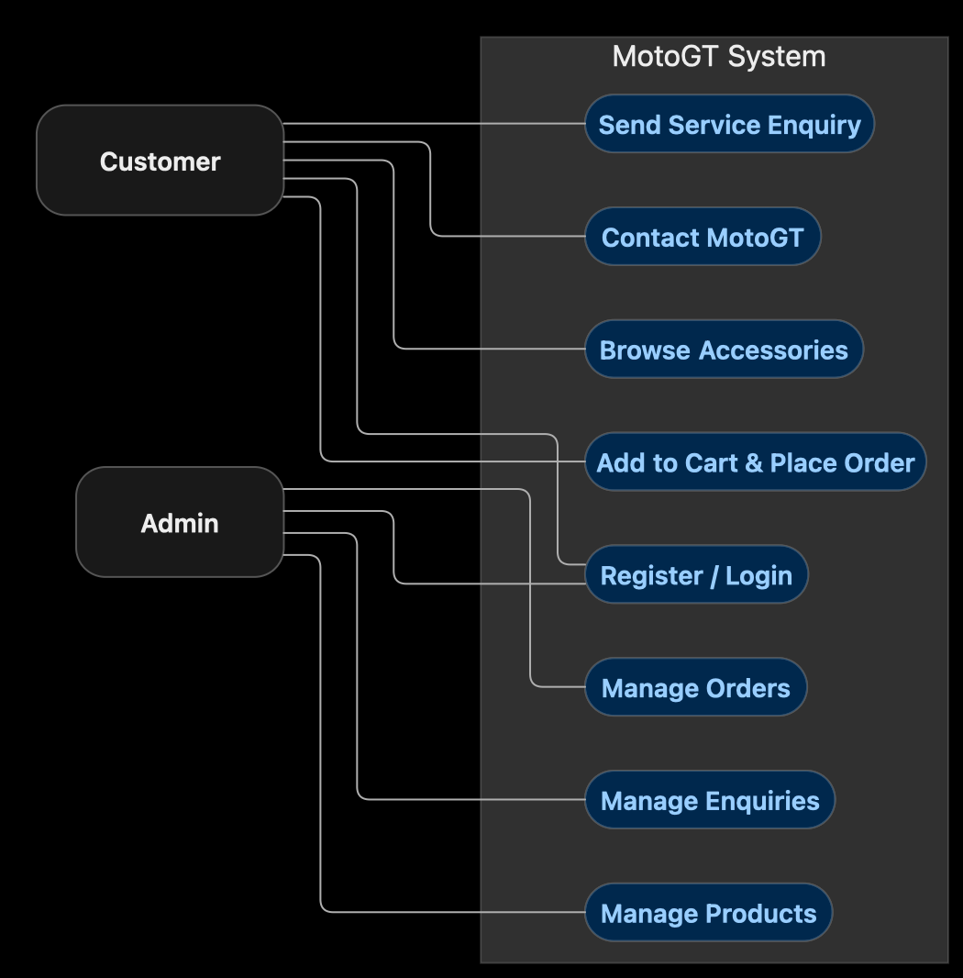
Figure 1: MotoGT Use Case Diagram
The use case diagram will illustrate the main actors and their interactions with the MotoGT system.
The primary actors are:
- Customer: Browses products, views product details, manages a cart, places orders, and submits enquiries.
- Administrator: Manages product listings, views and updates orders, and handles customer enquiries.

7.2 System Sequence Diagram
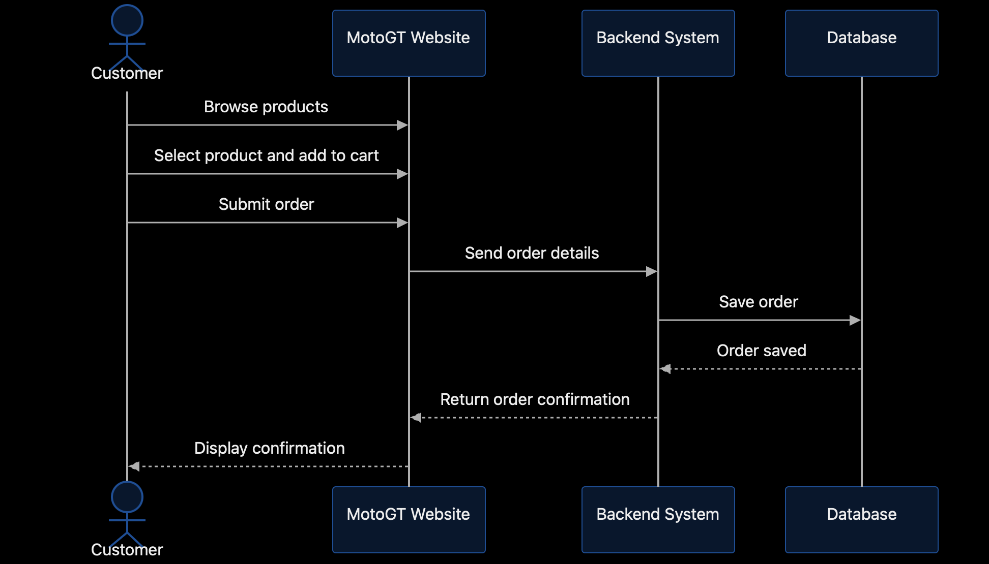
Figure 2: MotoGT System Sequence Diagram
The system sequence diagram will illustrate the sequence of interactions between a customer and the system during a selected operation, such as placing an order.
The sequence should show the customer's request, the system's response, validation of the submitted information, and the resulting confirmation or error message.

7.3 High-Level System/Prototype Diagram
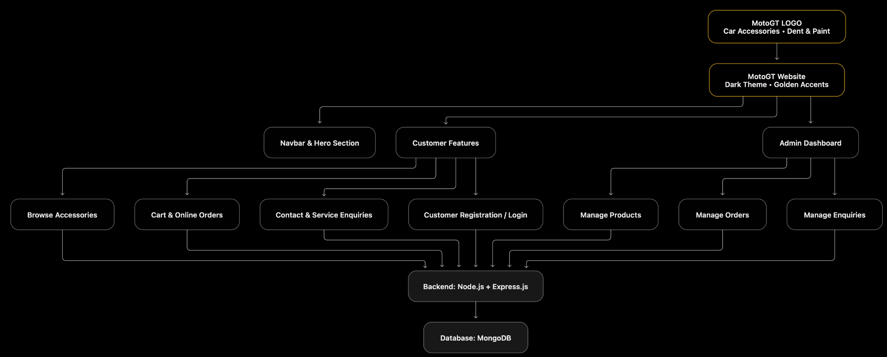
Figure 3: MotoGT High-Level System Overview
The high-level diagram will present the main components of the proposed system:
- Customer interface.
- Administrative interface.
- React.js frontend.
- Node.js and Express.js backend.
- MongoDB database.
- Development tools, including Visual Studio Code and Git/GitHub.
The diagram will show the conceptual relationship between these components. It does not need to match the final website interface exactly.

7.4 UI Wireframe
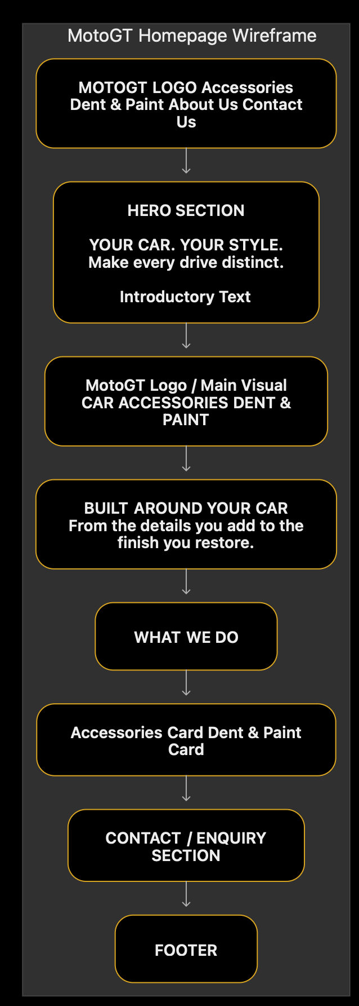
Figure 4: MotoGT Initial UI Wireframe
The wireframe will show the proposed arrangement of the homepage, logo, navigation menu, car accessories section, dent and paint services section, contact section, and footer.
The wireframe represents the initial layout plan and may change during development.

8. Project Scope
The planned scope of MotoGT includes:
- A responsive homepage and navigation menu.
- Car accessory product listings and product details.
- Automotive service information.
- Customer registration and login.
- Shopping cart and order placement.
- Customer contact and enquiry submission.
- An administrative dashboard for product, order, and enquiry management.
- Database integration and appropriate access control.
Online payment gateway and delivery-service integrations may be considered optional enhancements depending on the available time and project requirements.

9. Project Planning and Constraints

9.1 Development Plan
The project will be developed in stages:
- Define objectives and analyze requirements.
- Select technologies and prepare system design diagrams.
- Develop the frontend interface.
- Implement backend APIs and database integration.
- Develop authentication, cart, order, and administrative functions.
- Test the application and correct identified problems.
- Update documentation and prepare the final submission.

9.2 Time Constraints
The project must be completed within the deadline provided by the course instructor. Development tasks will be prioritized according to their importance, complexity, and available time.

9.3 Hardware Requirements
The project is expected to require:
- A desktop computer or laptop.
- Sufficient memory and storage for the development tools and application.
- An internet connection for downloading dependencies and accessing GitHub when required.

9.4 Software and Platform Requirements
The planned development environment includes Visual Studio Code, Node.js, npm, React.js, Vite, Express.js, MongoDB, Mongoose, Git, GitHub, and a modern web browser.

9.5 Team Management
Project responsibilities will be organized according to the actual team structure. If the project is developed individually, the developer will manage requirements, design, implementation, testing, and documentation.

9.6 Documentation and Version Control
Project requirements, diagrams, and development progress will be documented throughout the project. Git and GitHub will be used to track source-code changes and maintain project history.

10. Current Development Status
The frontend interface has been started using React.js and Vite. The initial interface provides a foundation for the remaining modules.
The backend API, database integration, authentication, shopping cart, order processing, and administrative dashboard must be verified or implemented before they can be reported as completed. Development progress will be updated as the project advances.

11. Final Submission and Evaluation Plan
The planned final submission will include the completed web application, source code, required system diagrams, updated project documentation, and relevant testing evidence, according to the instructor's requirements.
The application will be evaluated by checking the implemented functional requirements, responsive layout, basic security measures, data handling, and overall usability. Testing results will be documented after the relevant features have been implemented and tested.

12. Conclusion
MotoGT aims to provide a convenient online platform for car accessories and automotive services. This initial document defines the project idea, objectives, functional and non-functional requirements, selected technologies, initial system design, and development plan.
The document will be updated as development progresses so that the final submission accurately reflects the implemented system and its testing results.

